Design Document
EMR - PA

Overview
The goal of EMR-PA is to design and implement an educational Electronic Medical Record (EMR) system tailored specifically for the Clarkson University Physician Assistant (PA) program. Unlike commercial EMRs used in hospitals, this system is not intended for real patient care. Instead, it serves as a training platform where PA students can repeatedly practice clinical documentation and decision-making in a low-risk, educational environment.
The system will allow faculty instructors to create and manage fictional patient case scenarios, including patient demographics, medical history, and supporting materials such as imaging. This closely mirrors real-world EMR workflows that the users will encounter during clinical rotations. Thus, the frontend design of this project will be based on existing platforms, such as the EPIC and eClinicalWorks software. The backend and database design will be tailored to fit the user’s requirements as well as the Minimum Viable Product given a shortened timespan.

User Interaction

Upon opening the webpage, the user (student or faculty) will be directed to a login page. From here, the individual can choose to log in with a previously established account or register a new one.

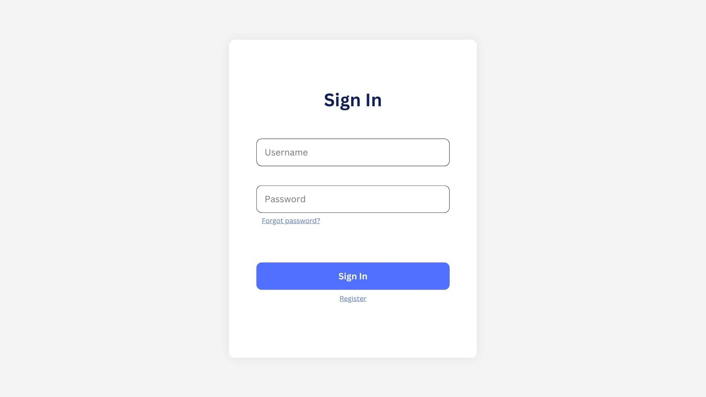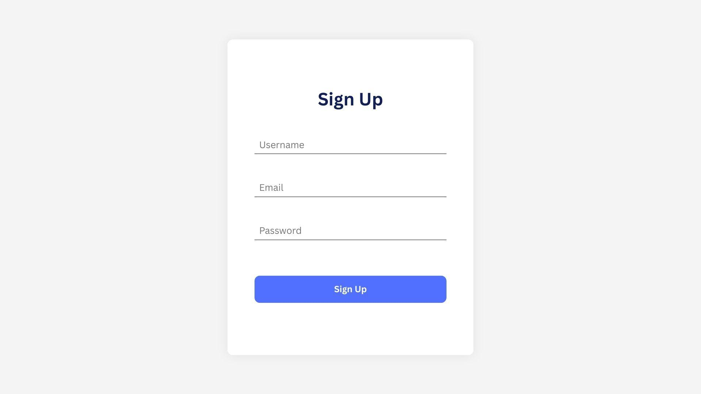

Once signed in, a student user will be redirected to the home page, where they will be able to view all assigned cases. At the top of every screen will be a navigation bar, including the software logo/name, a clickable “Home” button that returns the user to this home page, and a drop-down menu for logging out.

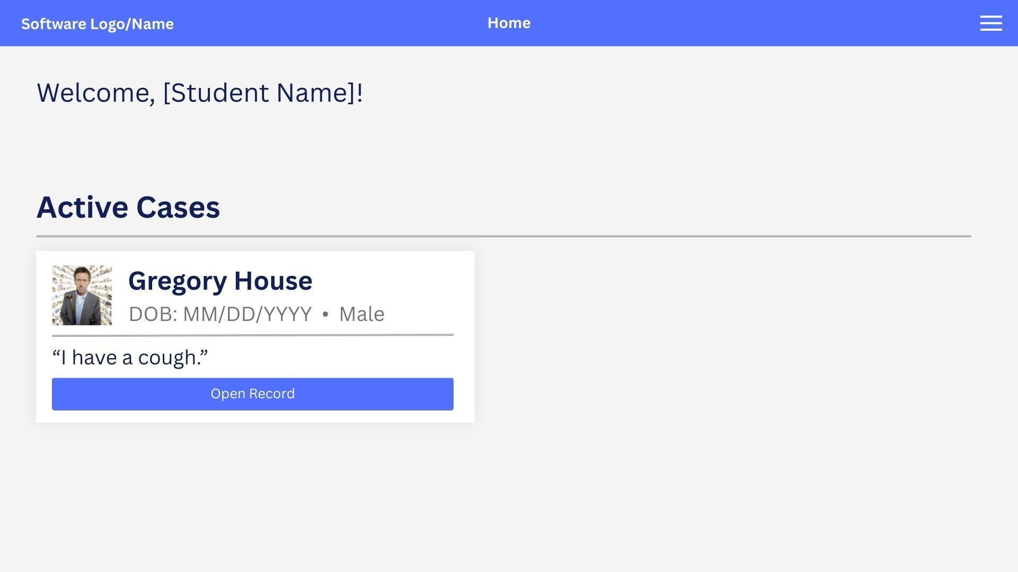

Each case will have its own page. On the main patient page, there will be a sidebar from which the student can select various screens, including HPI, medications, allergies, medical history, family history, social history, review of systems, physical exam, procedures, diagnosis, labs & diagnostics, treatment, coding & billing, learning issues, and documentation.

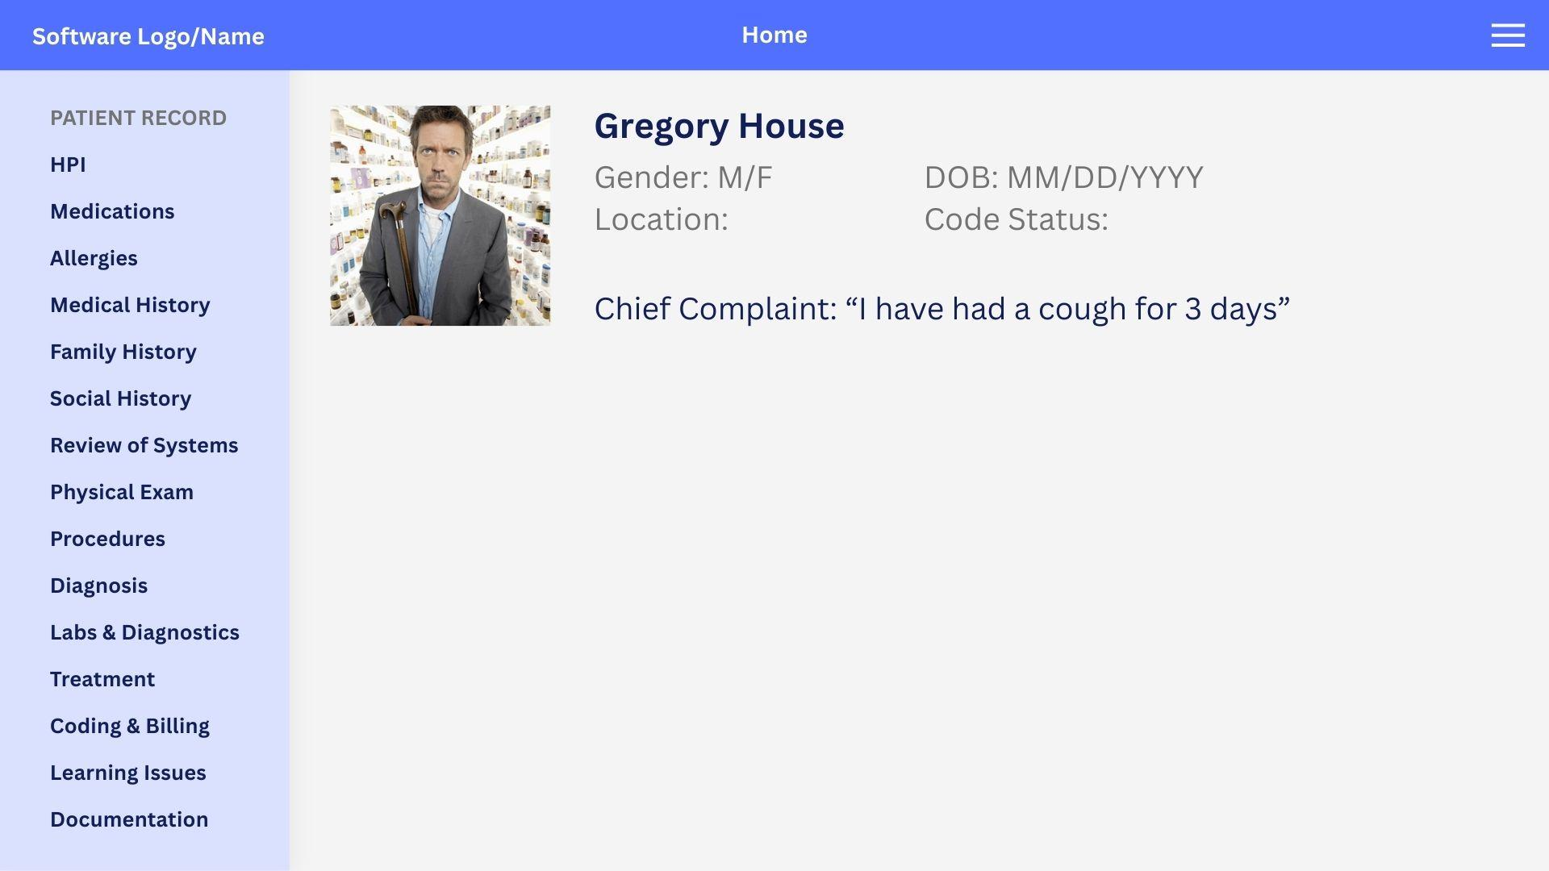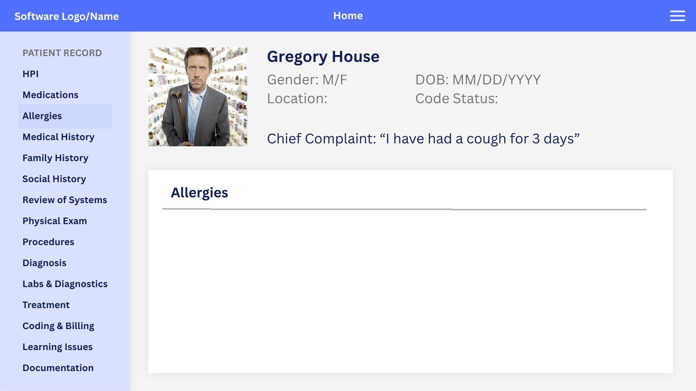

The majority of these screens will have only a blank form for students to take notes in (e.g., the “allergies” tab). However, there are a few notable exceptions, such as Diagnosis and Coding & Billing, which will have selectable codes for students to choose from.

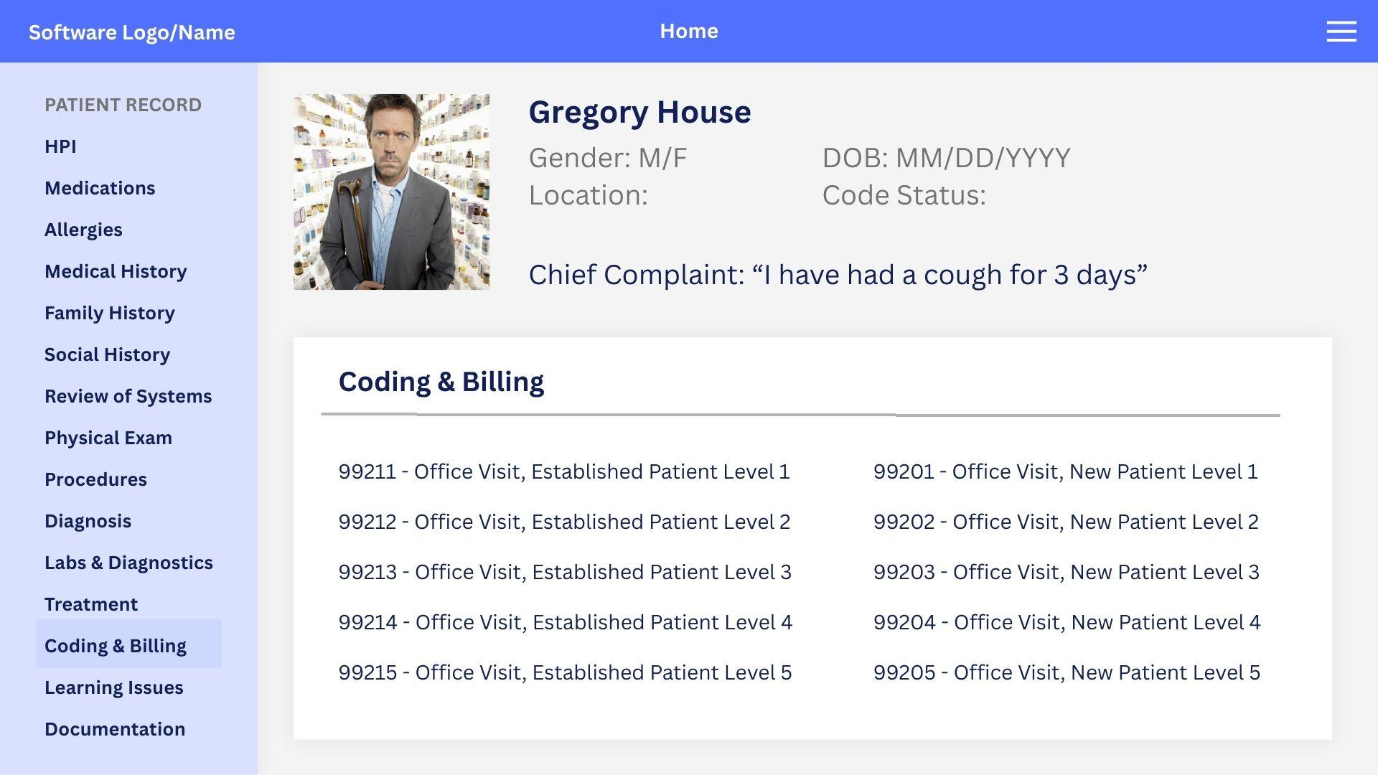

Faculty will be directed to a different dashboard upon logging in. This page will allow management of student assignments and creation of new cases.

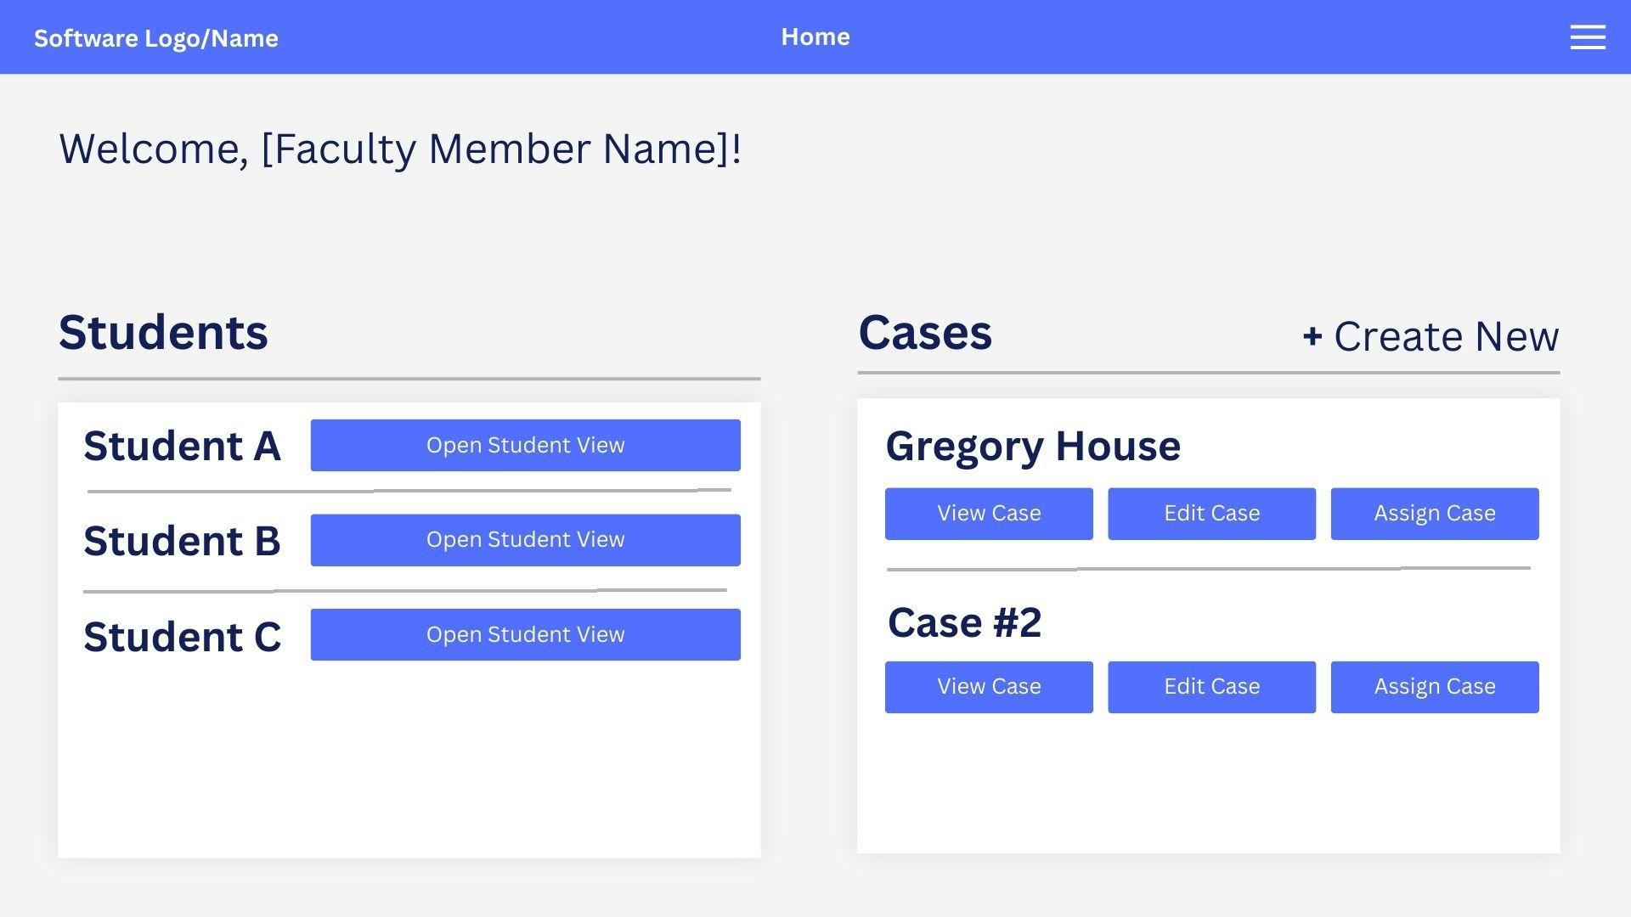

When a student's page is opened, it will look nearly identical to the student’s own view. However, faculty may be able to see items that are hidden from the student within each case assigned to that individual, such as in the Labs & Diagnostics tab, where instructors can toggle which labs are available to the student.

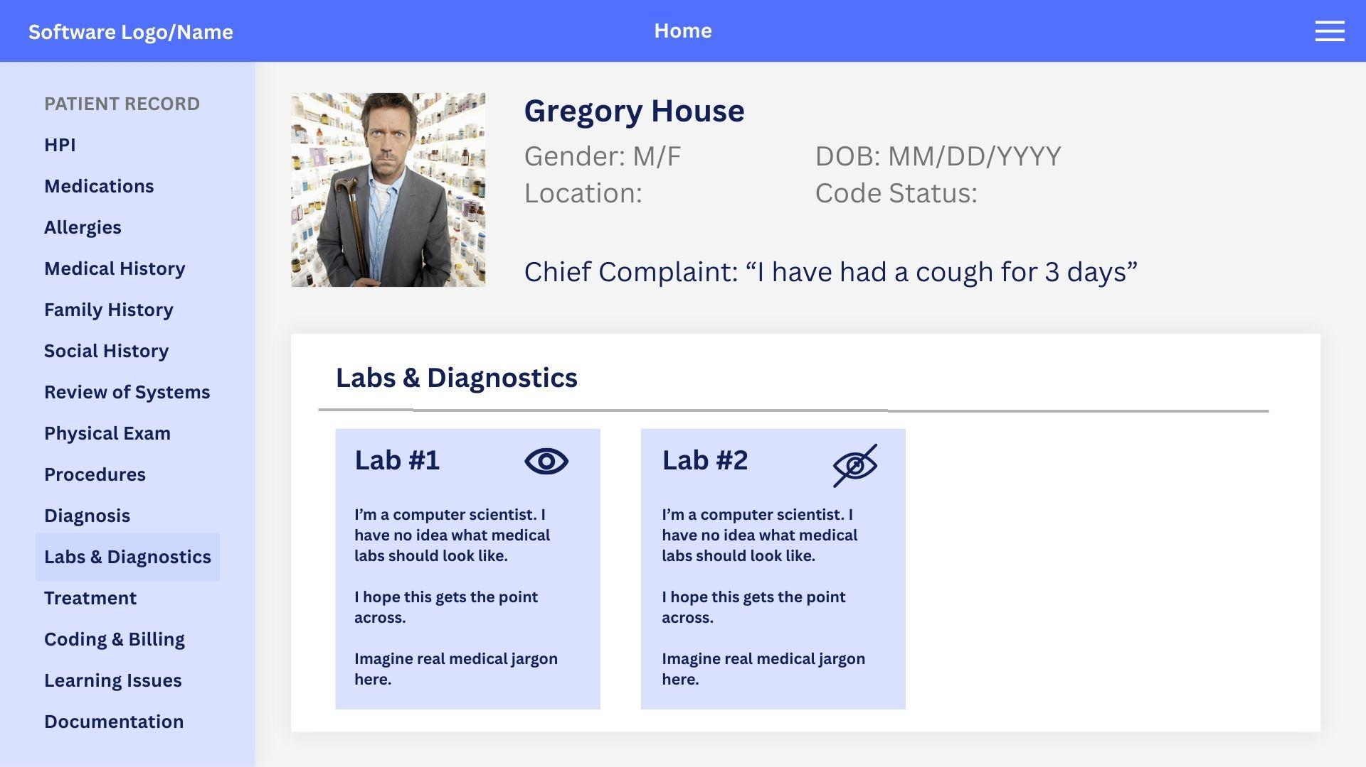

API Design

EMR-PA will use an internal REST API to connect the React frontend to the backend, which is written in Express. The API is responsible for moving data between the EMR user interface and the PostgreSQL database. Some examples are when a user performs an action such as logging in, opening a patient case, or saving a note, the frontend sends an HTTP request to the backend API, which then validates the request, checks permissions based on role, performs the appropriate database operation, and returns a JSON response. This clear separation of the system into layers makes the project easier to develop, test, and extend. For the MVP, the API should support logging in, case viewing, note creation, note editing, and faculty case management.

HTTP Methods Used

The API will primarily use four HTTP requests:

GET - This request is used to retrieve existing data stored in the database. In this EMR-PA, GET is used to fetch the currently logged-in user, retrieve available or assigned patient cases, open a case detail page, and load previously saved notes and instructor feedback. Only used for reading information.

POST - This request is used to create new records or submit input to the server. In this EMR-PA, a POST request is used when a user registers, logs in, creates a new note, creates a patient case, assigns a case, or adds instructor feedback. The reason login should be treated as a POST rather than a GET is that the user is submitting credentials to the backend.

PUT - This request is used to update existing information. In this project, a PUT request is used for things such as note saving, note editing, and case editing by instructors. PUT supports users returning to cases, continuing their work, and saving changes over time.

PATCH - This request is used for partial updates of existing information. This request is very useful for admin actions such as changing user roles from student to instructor, as it allows for only one field to be changed rather than replacing the full user record.

Authentication

Authentication is very important in EMR-PA, especially because it supports multiple user roles. This means that the API must enforce permissions very carefully to ensure users are restricted from tasks based on their roles. This will be done using JWT. After logging in, each user will receive a JWT token. This token is attached to protected requests using an authorization header. The backend middleware checks the token, identifies the user, and verifies their permissions before the request reaches the route logic.

The main permission rules are:

Students - can view cases assigned to them and create or edit their own notes

Instructors - can create and edit cases, assign cases to students, review submitted notes, and provide feedback

Admins - are allowed to manage users by approving or promoting users to instructors as well as performing demotions, deleting users, and other privileged tasks.

This way, users only get to see parts of the system that are relevant to their roles, and unauthorized access is prevented.

API Endpoints

Authentication Endpoints
Method | Endpoint | Use case
POST | /auth/register | Create a new account
POST | /auth/login | Authenticate the user and return a JWT
GET | /auth/me | Return logged-in user profile

Case Endpoints
Method | Endpoint | Use case
GET | /cases | List cases visible to the current user
GET | /cases/:id | Get case details
POST | /cases | Create a new patient case
PUT | /case/:id | Update an existing case

Note Endpoints
Method | Endpoint | Use case
GET | /cases/:id/notes | Load notes for a case
POST | /cases/:id/notes | Create a new note for a case
PUT | /notes/:id | Update an existing note
GET | /notes/:id | Retrieve a specific note

Assignment Endpoints
Method | Endpoint | Use case
GET | /assignment | View assignments for the current user
POST | /assignments | Assign a case to a student

Feedback Endpoints
Method | Endpoint | Use case
POST | /notes/:id/feedback | Add instructor feedback
GET | /notes/:id/feedback | View feedback for a note

Admin Endpoints
Method | Endpoint | Use case
GET | /admin/users | List users
PATCH | /admin/users/:id/role | Change a user’s role

Status Codes

Admin Endpoints
Code | Use case
200 OK | Successful read request
201 Created | Successful creation request
400 Bad Request | Invalid input
401 Unauthorized | Missing or invalid authentication
403 Forbidden | Users without the correct role
404 Not Found | Request for resources that do not exist
409 Conflict | Duplicate email submitted during registration
500 Internal Server Error | Unexpected backend failure

Identification of Modules

Module Overview:

This system is composed of six modules, designed to handle different aspects of the application functionality. Each module defines the responsibilities of the system like user authentication, data storage, and interactions between users. As well as outlining the different set of privileges each user has in the system.

This system contains the following main modules:

- Authentication (Login Page)
- Student View
- Faculty View
- Clinical Documentiation (Note Taking / Orders)
- Case management (Case Uploading)
- Database Architecture

Module Descriptions:

Authentication (Login Page)

Purpose:

The main purpose of the login page is to authenticate the user, and grant them access to the site. It will provide an interface where users can enter credentials. And a backend that will authenticate those credentials using secure password hashing. After a successful login, the user will be granted access to the appropriate view (Student View and Faculty View).

Interaction Diagram:

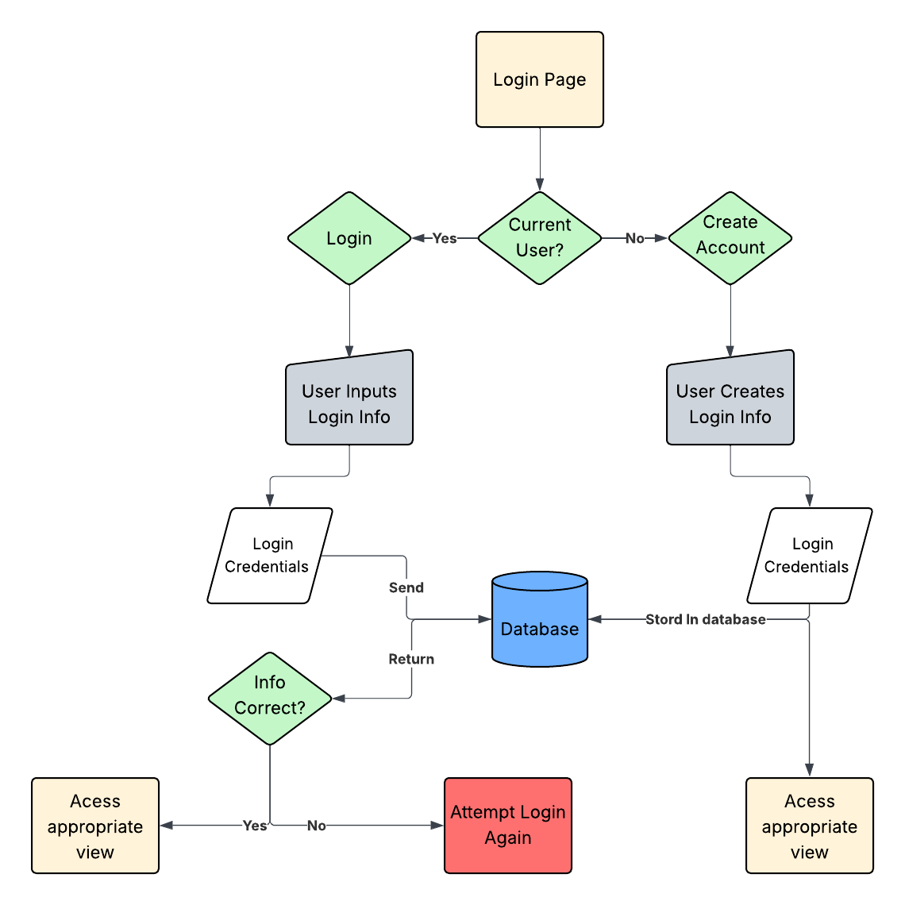

Responsibilities:

This module's responsibilities are centered in the authentication and redirection of the user. As well as clear and accurate communication between the database. Both to store and verify the user's credentials. All handled within the backend of the system. Built to ensure security and authentication.

- Verify user credentials
- Determine user role
- Send user credentials to the backend
- Encrypt store user credentials
- Store user credentials in database
- Retrieve user records from database

Inputs:

Inputs are largely centered around the user's interaction with the page. There are only three possible input fields in this page. And inputs will be treated with the same process in the backend. The user's registration status and assigned role will be stored within the backend.

- User email or username
- User password
- Authentication from backend

Outputs:

Outputs of the login page will be a direct result of the validity of the user's credentials. And the type of user that is logging in.

- Authentication confirmation from backend
- Redirect user to correct view (Student and Faculty)
- Error message if the users credentials are invalid

Communication with other Modules:

This module will predominantly communicate with the database. Sending the entered credentials to the backend to be compared with the stored credentials for that particular user. When a user submits their login information, the backend retrieves that user's record from PostgreSQL. The password entered by the user is encrypted and compared against the stored encrypted password.

Once the user has been authenticated, the system will determine the user's role. And redirect them to either the student view or faculty view.

Student View

Purpose:

The student view is the main focus of the EMR-PA project. Functionalities of the student page will include documenting the history of present illness (HPI), the ability to record exams, and create and order labs and imaging will also be included.

Interaction Diagram:

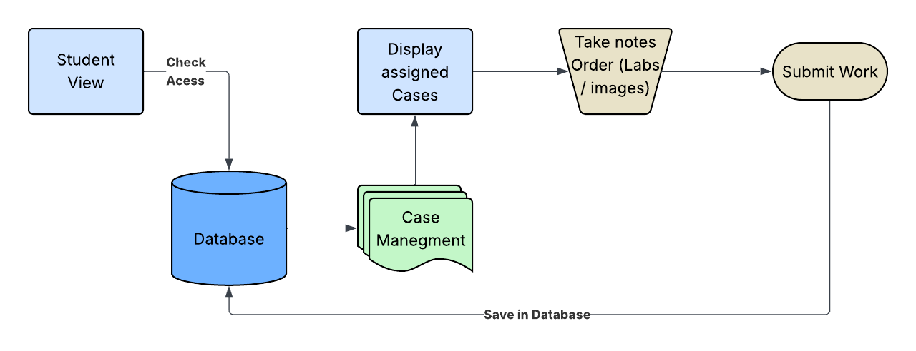

Responsibilities:

Documenting the patient’s HPI will appear as a page of multiple text fields on the frontend. Once submitted/ saved, the backend will use this button as a trigger to send the recorded information back to the database to be recorded.

The recording of physical examinations will work similarly, with different fields according to the nature of the medical procedures the user follows.

Due to the nature of mock patients, the ability to create and order labs will be mainly focused on a fulfillment of the labs being ordered. The labs will not be completed in this software, just ordered. This fulfillment will be viewable from the faculty changes and will also be stored in the database.

Inputs:

The student view module receives inputs from both the student interaction with the interface and case data retrieved from the backend.

Given the simplicity of the case data, which will consist of simple text files and photos. The user of this page will be able to read through the files much like a PDF reader.

Students will interact with these materials through the interface by navigational buttons. Allowing them to select the desired case to study. And move through the sections of that case, accessing different photos and text files.

They will also have the ability to order further imaging and labs for the patient. The type of lab they order will depend on their interpretation of the patient's current symptoms.

When a student has finished their session, they will have the ability to submit all work. As well as confirming that they have completed the case.

- Student interface (navigation through cases)
- Case data retrieval
- Order labs / imaging
- Session Submission (Taken notes, authentication of completion)

Outputs:

Outputs of this module will consist mainly of requests to retrieve case data from the PostgreSQL database. This information will be sent back to the user granted they have been given access to that case.

Once a student has submitted their work. All work completed by the student will be stored in the database. This includes all HPI notes written by the student. As well as any requests for labs, or imaging for the patient.

By submitting work, the student's completion of the case will be recorded on their profile. This will be represented in the system as a boolean value. This ensures that the faculty member can confirm the student has completed the case.

- Retrieval of case data
- Submission of HPI notes as
- Request for lab / imaging orders
- Case completion confirmation

Communication with other Modules:

The student view module will depend on direct communication between several other modules to function correctly. Authentication services are required to verify that the user has access to the system. As well as the permissions to view assigned cases.

Note taking is an essential aspect of the student view. So communication between the student view and note taking module provide the functionality necessary for students to document the History of Present Illness (HPI). Order clinical labs, further patient imaging, and other clinical notes during the session.

All clinical documents, including notes and lab or imaging orders created during sessions will need to be stored in the database. This requires the student view to have direct communication with the database module. This allows students to return to previously assigned cases, as well faculty review of documentation.

- Authentication module
- Clinical Documentation module
- Database module
- Case Management module

Faculty View

Purpose:

The faculty view is the second main component of the system. Giving the professors an interface to upload case files, assign cases to students. And manage the overall structure and layout of each sequential case. Effectively serving as the systems administrators.

Interaction Diagram:

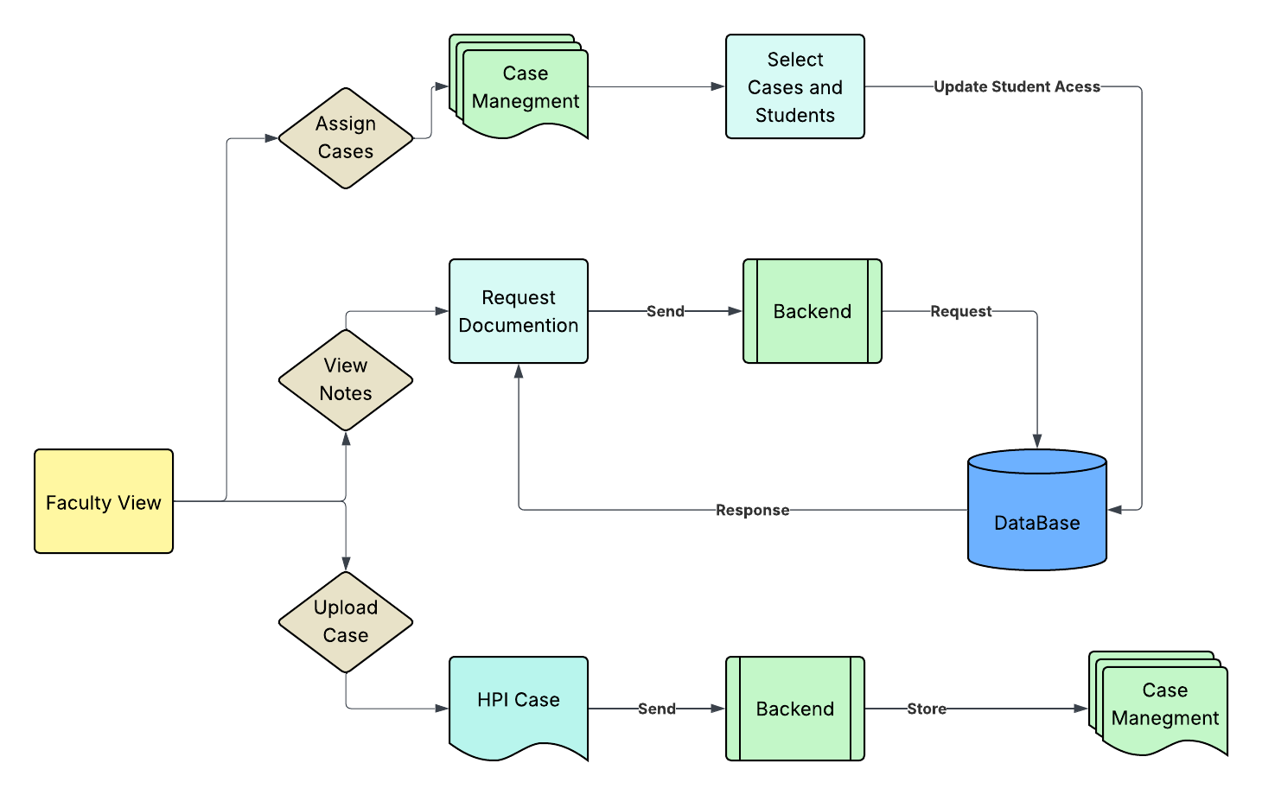

Responsibilities:

The Faculty View serves as an interface to perform administrative and instructional functions in the EMR - PA system. The main responsibilities are outlined below.
Faculty members can upload patient case information, including text documents, images and other required patient information to simulate each case.

The module also allows faculty members to assign students with specific cases based on the topics currently being studied. Ensuring students are working with materials relevant to learning objectives.

Evaluating and reviewing students' documentation is another key responsibility of this module. Faculty will have direct access to documentation made by the students during sessions. Feedback from the faculty will be provided outside of the system in an in-person environment.

- Upload patient cases
- Assign student cases
- Monitor student progress
- Evaluate student notes and orders

Inputs:

The faculty view module will receive inputs primarily from the faculty interaction with the system interface. And retrieval of student documentation stored in the system database.

Faculty members interact with the interface to upload and manage case materials. These materials, as mentioned above, will contain text files, images, and any other patient information prominent to the case.

Faculty members will also provide input when assigning a case to a specific student. Through the interface, faculty members will be able to assign cases to individuals or groups centered on the topic currently being discussed.

Another important input from the faculty will be the retrieval of student notes and orders. By means of selecting students, and browsing completed cases. The subsequent case will be requested from the database.

- Faculty navigation actions
- Uploaded case information
- Student documentation records

Outputs:

The faculty view will receive outputs based on the request made by the faculty member. Through interaction with the systems interface. Predominantly through the creation and modification of current cases and student assignments.

The creation of a case will generate an output from this module. Sending all uploading information and images to the backend of the system. Subsequently saving that data to the cloud for later assignment to the student.

Case assignment will be another important output from this module. Once a professor has decided on which case to assign which students. They will be able to select from all students and cases. Generating an output that will update student and case allocation.

- Case creation requests
- Case assignment updates

Communication with other Modules:

The faculty view will have vital communication with three of the other main modules of the system.

Before a faculty member can create and update any form of case information. Their account will need to be authenticated to confirm faculty status. This process will be run multiple times throughout the program to maintain proper security between student and faculty views.
The creation of cases and all HPI data will be an operation present to faculty members through the system interface. Connection to the case management system module is essential for maintaining both the organization and storage of uploaded material.

The assignment and provided access to cases is a user by user privilege. A faculty member will be given the ability to alter these privileges. To accomplish this, a connection to the user database will be maintained between the faculty view module and the database architecture.

- Authentication Module
- Case management Module
- Database Module

Clinical Documentiation (Note Taking / Orders)

Purpose:

This module will handle the creation and proper storage of user created notes produced by students. Maintaining the organized and well categorized storage of these documentations in the database will make access from other modules easy.

Interaction Diagram:

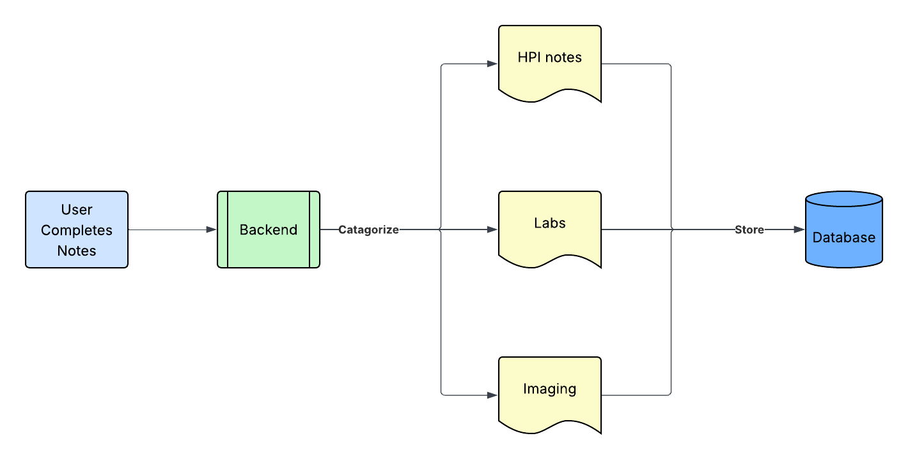

Responsibilities:

Throughout a student's case review session, they will be required to take notes pertaining to presented case data. To facilitate this, the clinical documentation serves to handle all required responsibilities related to saving all student documentation.

Once a student has ended their session, and submitted all their documentation. Including HPI notes, and lab and imaging orders. This data will be saved to the database under their user account.

- Save HPI documentation
- Save physical exam notes
- Record lab and imaging orders

Inputs:

The clinical documentation module will receive inputs from user interaction with the interface. As well as identifying current cases, and student ID. To store documentation under the proper student account and mark correct cases as complete.

- Student clinical entries
- Case identifiers
- Student user ID

Outputs:

The output of this module will compile, categorize, and store the notes produced by the student. Classifying the separate types of student documentation in a format to be stored in the database architecture. The student's completion of the case will also be marked and updated under their account.

- Stored clinical notes
- Lab and imaging order records
- Case completion status

Communication with other Modules:

The clinical documentation module communicates with two primary system modules. Student view relies on this component to allow students to create and manage clinical documentation during their sessions. Through this interaction of modules, notes are prepared and stored within the systems database architecture.

- Student View module
- Database module

Case management (Case Uploading)

Purpose:

The Case Uploading module provides functionality for faculty members to upload patient case materials to the system. Uploaded files, including documents, images, and other case-related information, are processed and stored within the database architecture for later retrieval and assignment to students.

Interaction Diagram:

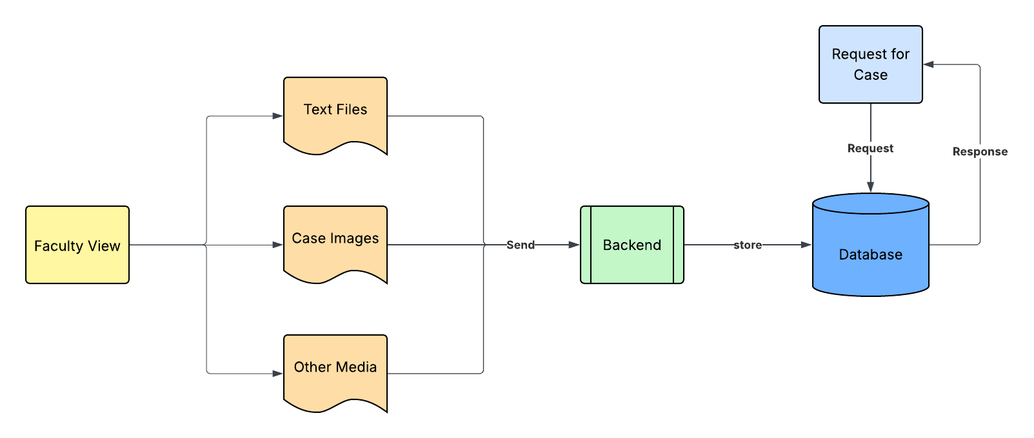

Responsibilities:

The case management module handles all tasks related to uploading, organizing, and assigning patient cases. Faculty use this module to provide case materials, including text documents, patient demographics, and medical images. Once uploaded, the module ensures that cases are properly stored and linked to the correct students for review.

- Store patient demographic data
- Upload case descriptions
- Upload medical imaging
- Assign cases to students

Inputs:

This module receives inputs from faculty interaction with the interface. Inputs include case files, patient information, and any supporting images needed for the simulation. The module also takes assignment details specifying which students or groups should have access to the cases.

- Case files uploaded by faculty
- Patient demographics
- Imaging files

Outputs:

The outputs of this module include organized case data ready for student access. Case metadata and uploaded materials are saved in the database, ensuring that students can view and interact with the cases assigned to them.

- Case data available to students
- Case metadata stored in database

Communication with other Modules:

The case management module works closely with the faculty view for uploading and assigning cases, the database module for storage, and cloud storage if needed for images or large files. This allows student and faculty modules to access and manage case data seamlessly.

- Faculty View module
- Database module
- Cloud storage

Database Architecture

Purpose:

The database will store data for many different use cases. The following different types will be stored:

- Login Credentials (Student and Faculty)
- Case/ Patient Data (Student View)
- Fulfillments for Ordered Labs (Student View)
- Possible Grades to Cases, If Time (Faculty View)

DB Schema:
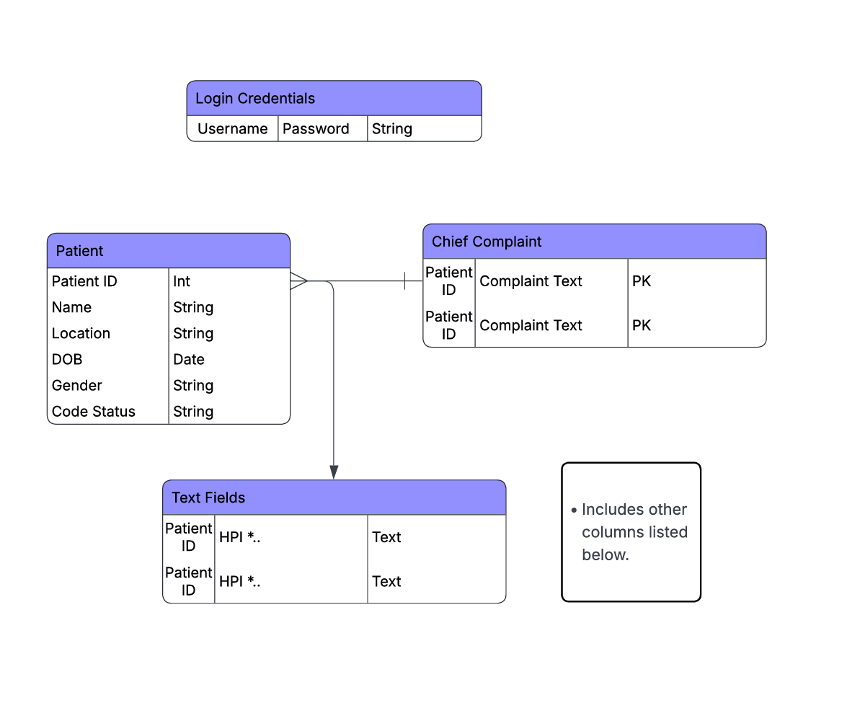

Responsibilities:

The database is responsible for storing data such as login credentials, information saved from the Student View, and information stored from the Faculty View. The database must efficiently organize and relate tables storing necessary information so that it may be accessed and edited or viewed by the necessary users.

Since nearly all other modules rely on the saving or accessing of information to the database, it will serve as the backbone of the EMR-PA project.

All patient and case information will be identifiable via the Patient ID, created upon a patient entering the system, assuming there are no repeated patients due to the mock nature of the software. A new patient ID will be created for every entry.

Functionality:

The inputs for the initial patient data is as follows:
- Patient Name (text)
- DOB (date)
- Gender (char)
- Location (text)
- Code Status (text)
- Chief Complaint (text)
The following fields will also be stored, all as strings for fields of free text with the exception of Coding and Billing, which is type Int:
- HPI
- Medications
- Allergies
- Past Medical History
- Family History
- Social History
- Review of Systems
- Physical Exam
- Procedures
- Diagnosis
- Labs and Diagnostics
- Treatment
- Coding and Billing
- Learning Issues
- Documentation Tab

Login information can easily be stored in a table containing the following:
- Username
- Password

Connections to Other Systems

Essentially, the entire web app is going to be hosted on the cloud, or a virtual machine from the COSI Lab. Using a virtual machine will most likely be better because it will cost us nothing to obtain, performance is usually good, and we will have full root access. The only potential downside is that we would have to wait for the IT team to set it up for us. Although Google Cloud can be set up instantly and provides full root access, its performance is very limited, and we can easily incur costs if we are not careful.

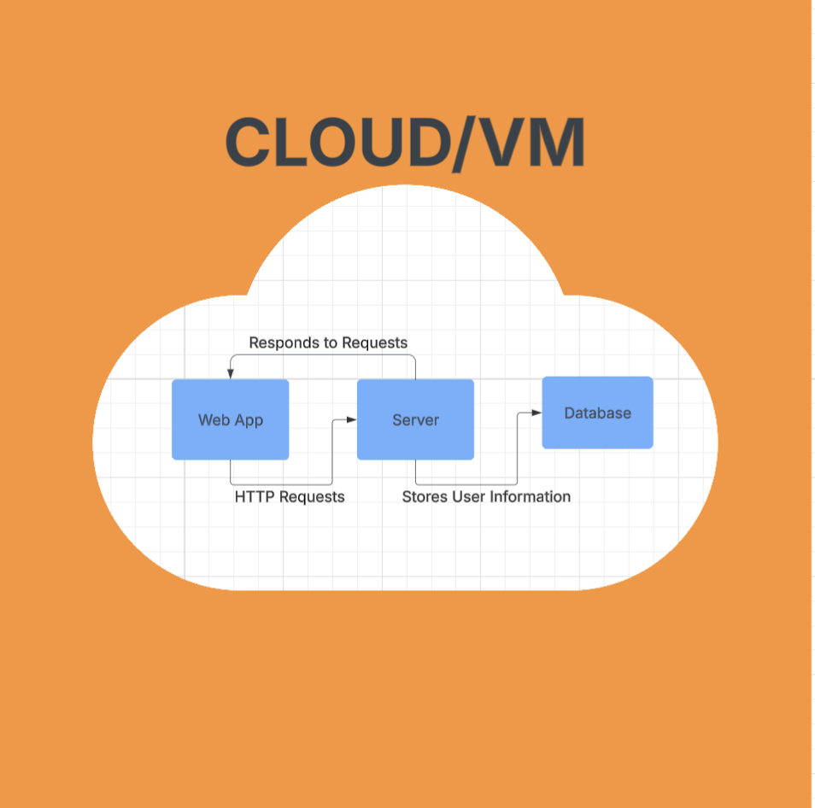

References

GitBook, GitHub, README’s, Postman. References serve as design documentation templates rather than cited sources for information we’ll be using.

